TEST 16.2
1.
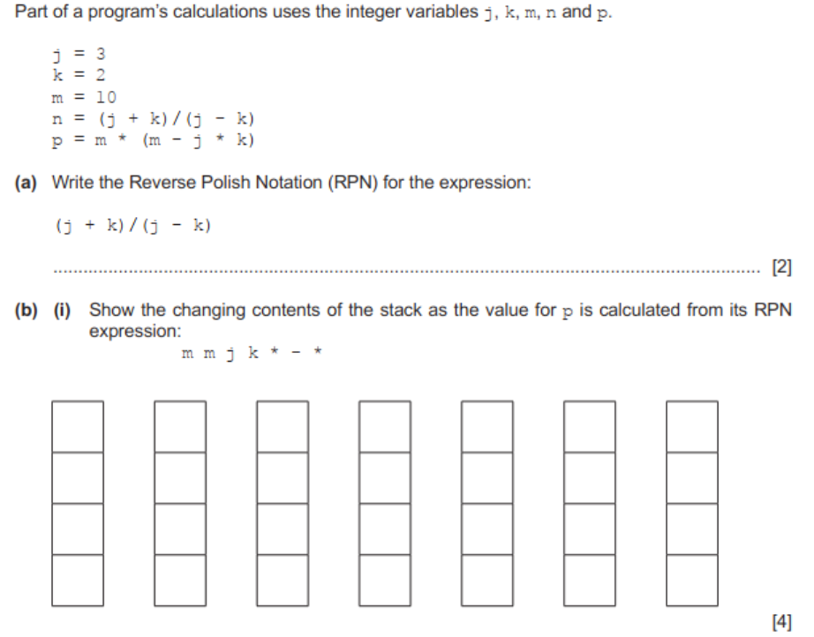

2.
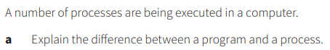

3.
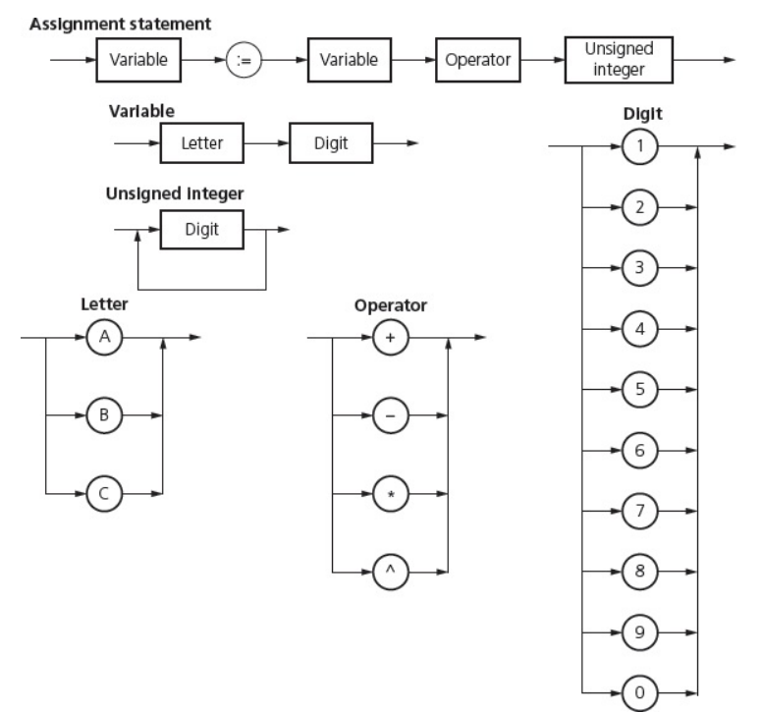

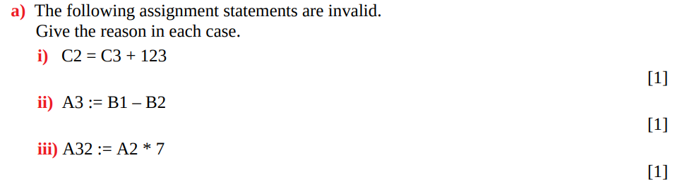

1.
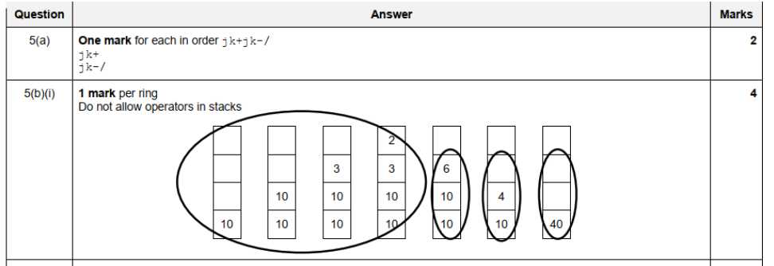

2.
The first part of the answer is the statement that a process refers to a program that has been loaded into memory and the execution of the program has begun. There are a number of possible statements about a program. The program could be the source code or the executable code. In the context of this question it is best to define the program as the code that is not being executed.

3.
